D840R-How to limit certain computer to access Internet by (Parental Control function)?
Product line: ADSL Question Category: Function configurations

Q: why we need to set Parental Control?
A: Sometimes we want to limit some computers in the LAN to access the Internet; we can achieve this through Parents Control.

I. Physical connection:
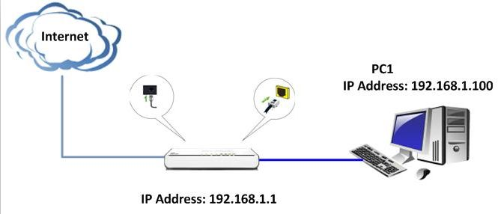
II. Login to the management page of the router:

1. Open a web browser (IE, Firefox, Safari, etc.) and find the address bar, leaving it blank before typing in 192.168.1.1, and then press enter.
(Care: The address bar is in the most top of the web page after opening web browser).
2. Input default username and password:admin in the following window, then click ok.
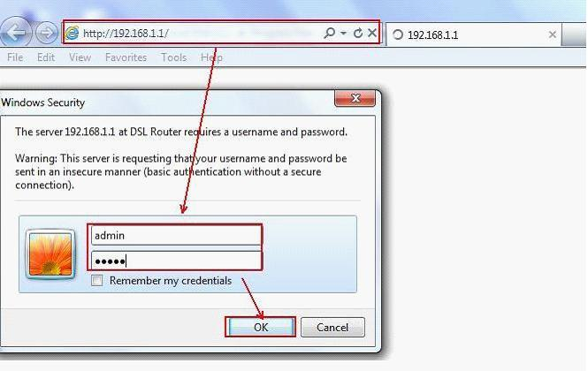
3. Please click Advanced Setting →Security->Parental Control. Click Add to create a new rule.
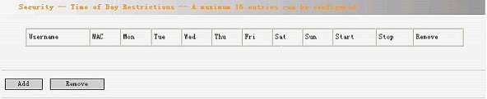
4. Then you will see the page below.

Take an example to show you how to do the settings.
Do the settings according to the following page, and click on Save/Apply to finish.
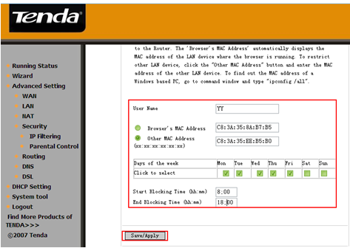
After the settings, the computer with MAC address C8:3A:35:EE:B5:B0 can not access the Internet from Monday to Friday (8:00-18；00).

Note：
This page adds time of day restriction to a special LAN device connected to the Router. The Browser's MAC Address automatically displays the MAC address of the LAN device where the browser is running. To restrict other LAN device, click the Other MAC Address button and enter the MAC address of the other LAN device.

To find out the MAC address of a PC, you should go to command prompt window and type in ipconfig /all, and then you will find a physical address, that’s the MAC address.

